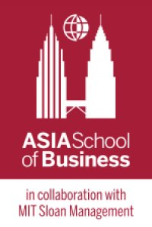 | ASB ALL-ASEAN Digital Marketing CLASS IV  Program Schedule: October 1 – October 2, 2020
 |  | Thursday  October 1st, 2020 | Friday  October2nd, 2020 |  |  |  | Saturday  November 27t^{h}, 2020
7:00 A morning run with Prof (optional)
|
8:00
AM |  | 8:15  Welcome Breakfast | 8:15  Breakfast |  | 4 WEEKS OF CAMPAIGNING OPPORTUNITY
 |  | 9:00  Welcome – TBA  Introduction  Willem Smit (ASB)  Hack 1: Target Persona & UX  Willem Smit (ASB) | 9:00  Hack 4: Paid Social (2): FB,IG,TikTok  Willem Smit (ASB)  10:00  Hack 4: Organic and Paid Social  tba
PM |  | 12:15  Lunch | 12:15  Lunch |  |  |  | 12:15  Lunch
 |  | 13:45  HACK 2: Search / SEO  tba  Hack 3: Paid Search  tba  Hack 4: Paid Social (1): Youtube  Jia Wen Chuah (Google)  17:00 | 14:30  Hack 5: Email+CRM  tba  Hack 6: Campaign Management  Willem Smit (ASB)  17:00 |  |  |  | 13:30  Post-Campaign Report –  TBA  Future of Digital –  Willem Smit (ASB)  17:00 End of class
Version: August 25, 2020, Program Director: Willem Smit

